Sri Lanka Institute of Information
Technology


IT2011 – Artificial Intelligence and Machine Learning
Year 2 semester 1
Group 7
Lung Cancer Survival Prediction
Evaluation Metrics

Registration no | Name
IT24103014 | Abeysinghe J.H.C.M
IT24103005 | Gunawardhana M.D.K
IT24103049 | Ransith K.A.K
IT24102922 | Ahangama A.V.D.S
IT24102935 | Rajamanthree R.M.K.V
IT24103084 | Karunanayake K.M.C.N

Evaluation and Comparison

The abnormal decrease in model performance metrics is caused by the high imbalance of the dependent variable. Because one class heavily outweighs the other, the model tends to favor the majority class, making it difficult to achieve high accuracy or balanced predictions even with extensive training or tuning.

Metrics

- Logistic Regression
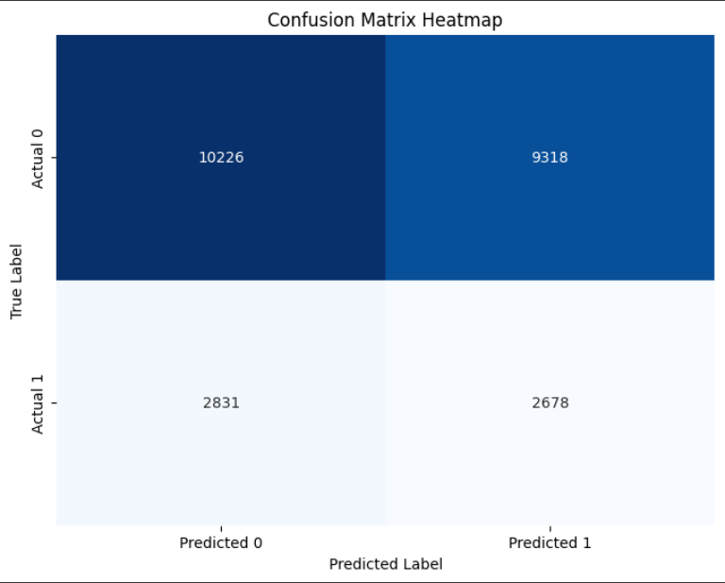
- Without handling the class imbalance
- Accuracy: 0.7801
- Precision: 0.0000
- Recall: 0.0000
- F1-score: 0.0000
- With handling class imbalances and
hyper-parameter tuning
- Accuracy: 0.5151
- Precision: 0.2232
- Recall: 0.4861
- F1 Score: 0.3060

- Decision Tree Classifier
- After handling class imbalances and hyperparameter tuning
- Accuracy: 0.5352
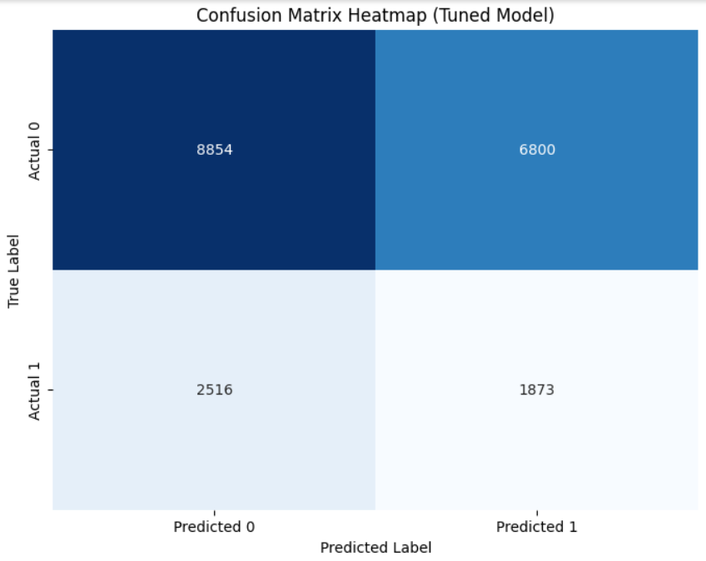
- Precision: 0.2160
- Recall: 0.4267
- F1 Score: 0.2868

- k-Nearest Neighbors (k-NN) Classifier
- After handling class imbalances and hyperparameter tuning
- Accuracy: 0.6286
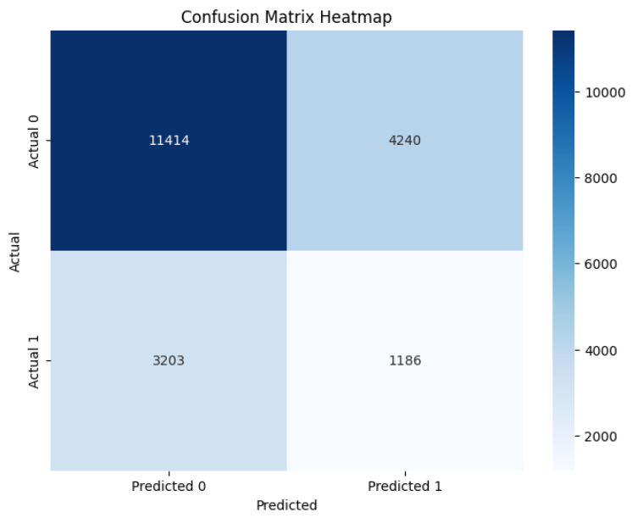
- Precision: 0.2186
- Recall: 0.2702
- F1-score: 0.2417

- Random Forest Classifier
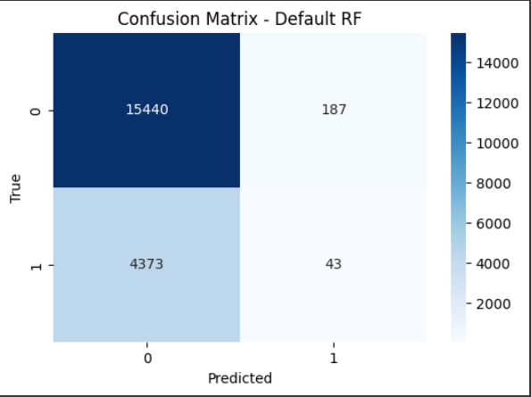
- Default Random Forest
- Accuracy: 0.7725
- F1 Score: 0.0185
- Precision: 0.1870
- Recall: 0.0097
- AUC-ROC: 0.4978

- Tuned Best Random Forest
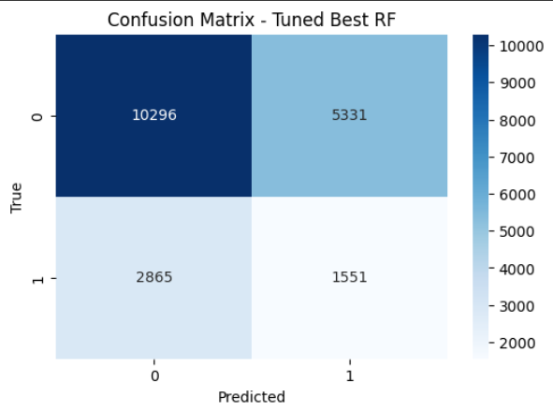
- Accuracy: 0.5911
- F1 Score: 0.2746
- Precision: 0.2254
- Recall: 0.3512
- AUC-ROC: 0.5050

- Shallow Random Forest
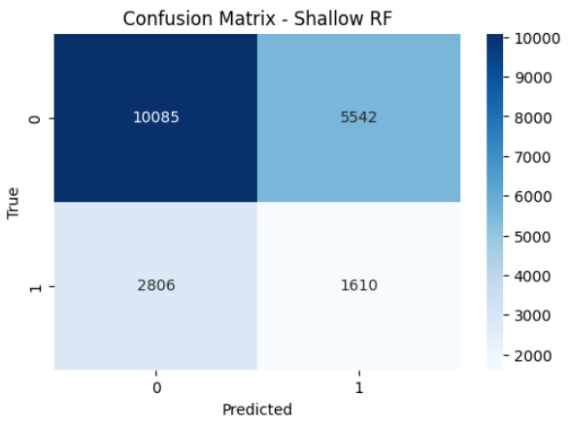
- Accuracy: 0.5835
- F1 Score: 0.2784
- Precision: 0.2251
- Recall: 0.3646
- AUC-ROC: 0.5047

- Naive Bayes Classifier
- Both with and without handling class imbalances
- Accuracy: 0.7797
- Precision: 0.2400
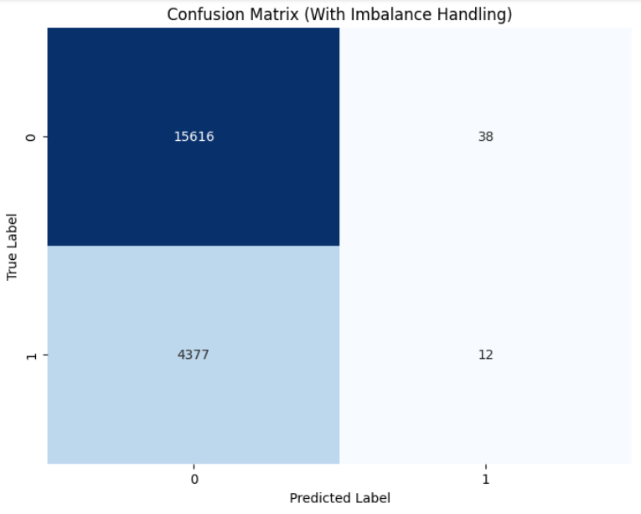
- Recall: 0.0027
- F1 Score: 0.0054

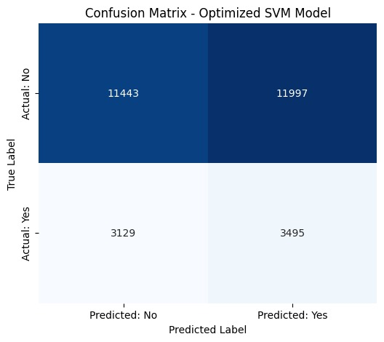
- Support Vector Machine (SVM)
  - After hyper-parameter tuning
- Accuracy: 0.4969
- Precision: 0.2256
- Recall: 0.5276
- F1 Score: 0.3161

Best Model with highest metrics

- Tuned SVM
- It has the highest F1-score (0.3161) and the highest recall (0.5276), meaning it finds the minority class more often than any other model while keeping a reasonable precision (0.2256). For imbalanced problems, F1 and recall are the most informative metrics.
- Metrics: Accuracy 0.4969, Precision 0.2256, Recall 0.5276, F1 0.3161.

